Tools in LangChain | Generative AI using LangChain
https://www.youtube.com/watch?v=etnLX7m2MiA&list=PLKnIA16_RmvaTbihpo4MtzVm4XOQa0ER0&index=18
https://docs.langchain.com/oss/python/integrations/providers/overview
https://colab.research.google.com/drive/1GHHGsDFB5266Cc0xDsZ6OWzkB5GGSxFW?usp=sharing
00:00 – Intro
01:48 - Overview
03:05 - What is a tool?
11:53 - Built-in Tools
20:56 - Custom Tools
31:05 - Create Custom Tools
41:03 – Toolkits
Introduction
Part 1: LangChain Fundamentals
- Core LangChain components
- Models
- Prompts
- Chains
Part 2: Retrieval-Augmented Generation (RAG)
- Document Loaders
- Text Splitters
- Vector Stores
- Retrievers
- Building a complete RAG-based system
Part 3: Agents (New Section)
In this section (3–4 videos), we will cover:
- Tools (this video)
- Tool Calling
- Agents using LangChain
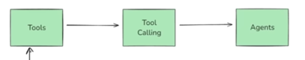
This video lays the foundation by explaining what tools are, why they are needed, and how they fit into the agent workflow.

What is a Tool?
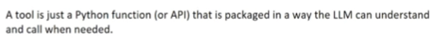
To understand tools, we must first understand the capabilities and limitations of LLMs.
Core Capabilities of LLMs
Modern LLMs have two main strengths:
- Reasoning (Thinking)
They can understand a question and reason step by step about how to answer it.
- Language Generation (Speaking)
Once reasoning is done, they can generate a well-structured natural language response.
In short, LLMs can think and speak.
Limitations of LLMs
LLMs cannot perform real-world actions on their own. For example, they cannot:
- Book a train ticket
- Fetch live weather data
- Reliably solve complex math problems
- Execute code
- Call external APIs
- Interact with databases
- Post on social media
Simple Analogy
Think of an LLM as a human brain without hands and legs:
- It can think
- It can talk
- But it cannot do things

Why Tools Are Needed
Tools provide LLMs with hands and legs.
A tool allows an LLM to:
- Execute tasks
- Interact with external systems
- Fetch real-time data
- Run code or commands
Technical Definition
A tool is a function (usually a Python function) that is packaged in a way that an LLM can understand and call when needed.
How Tools Work (High-Level Flow)
- User asks a question
- LLM decides whether a tool is needed
- LLM calls the appropriate tool with inputs
- Tool executes the task
- Tool returns the result to the LLM
- LLM generates the final response
Example
- Question: “What are the trains from Delhi to Mumbai?”
→ LLM answers using knowledge
- Follow-up: “Book a ticket in that train”
→ LLM uses a booking tool to perform the task
The more tools you add, the more tasks your LLM can perform.

Tools and Agents: The Connection
What is an AI Agent?
An AI Agent is an LLM-powered system that can autonomously think, decide, and take actions using external tools and APIs to achieve a goal.
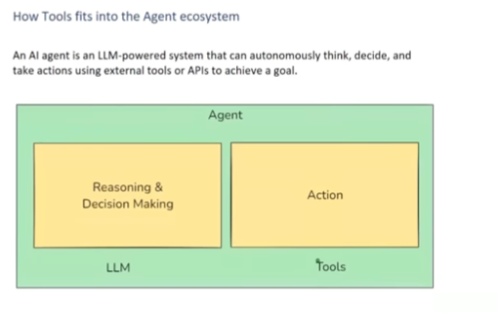
Agent Capabilities
An agent has two key abilities:
- Reasoning & Decision Making (powered by LLMs)
- Taking Actions (powered by tools)
Key Insight
LLM + Tools = Agent
Without tools, an agent cannot take action. That’s why tools are a core requirement for building agents using LangChain or LangGraph.

Types of Tools in LangChain
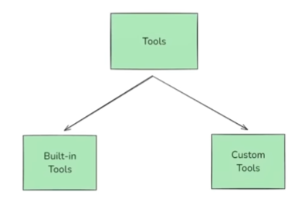
LangChain provides two categories of tools:
1. Built-in Tools
These are prebuilt, production-ready tools provided by LangChain.
- Minimal or no setup required
- Just import and use
Common Built-in Tools
- DuckDuckGo Search – Web search
- Wikipedia Query – Fetch topic summaries
- Python REPL Tool – Execute Python code
- Shell Tool – Run terminal commands
- HTTP Requests Tool – Call APIs
- Gmail Tool – Send emails
- Slack Tool – Send Slack messages
- SQL Database Tool – Run SQL queries
These tools cover many common real-world use cases.

2. Custom Tools
If a built-in tool does not match your use case, you can create your own.
Typical scenarios:
- Company-specific workflows
- Internal APIs
- Custom business logic
You define:
- The function logic
- Input parameters
- Output format
Then connect it to the LLM.

Using Built-in Tools: Examples
DuckDuckGo Search Tool
Use case: Fetch real-time information from the web.
Example scenarios:
- Latest news
- Live events
- Current trends
Behind the scenes:
- Query is sent to DuckDuckGo
- Search results are returned
- LLM uses them to answer the user
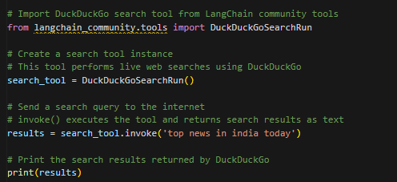
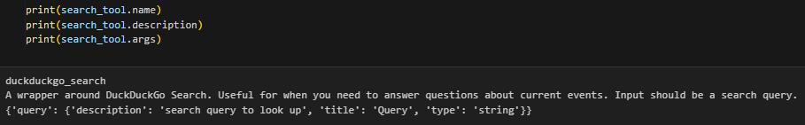

Shell Tool
Use case: Run command-line commands on the system where the code is running.
Examples:
- whoami – Check current user
- ls – List directory contents
⚠️ Warning: This tool is powerful but risky.
- Can modify or delete files
- Use carefully, especially in production
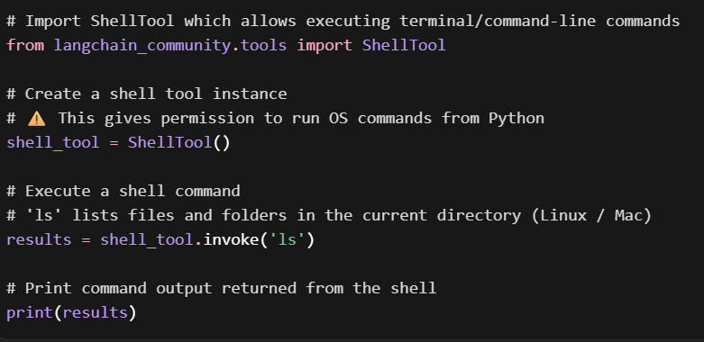

Exploring All Built-in Tools
LangChain provides extensive documentation listing:
- Available tools
- Their purpose
- Sample working code
- Agent integration examples
You can explore tools by category:
- Search
- Code execution
- Productivity
- Web browsing
- Databases
- Finance
Each tool comes with clear usage instructions.
Custom Tools in LangChain
When Do You Need Custom Tools?
You need custom tools when LangChain’s built-in tools are not sufficient for your specific use case. This situation commonly arises when you already have an existing application or backend infrastructure and want an agent to interact with it.
Common Scenarios for Custom Tools
- Calling Your Own APIs
If your application exposes internal APIs, the agent must use them to perform actions. For example, in a travel-booking platform like MakeMyTrip, an agent should not only chat with users but also:
  - Book flights or hotels
  - Check availability
  - Update booking records
Since these APIs are proprietary, LangChain cannot provide built-in tools for them. You must create custom tools that wrap these APIs.
- Encapsulating Business Logic
Many applications contain domain-specific business rules that are unique. These rules cannot be generalized into built-in tools, so they must be exposed to the agent through custom tools.
- Interacting with Your Own Databases or Products
If an agent needs to read from or write to your own database, internal product, or application, custom tools are required.
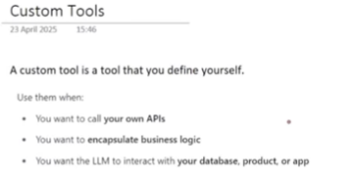
In short: whenever you already have an application and want an agent to work with its existing infrastructure, you must build the required tools yourself.
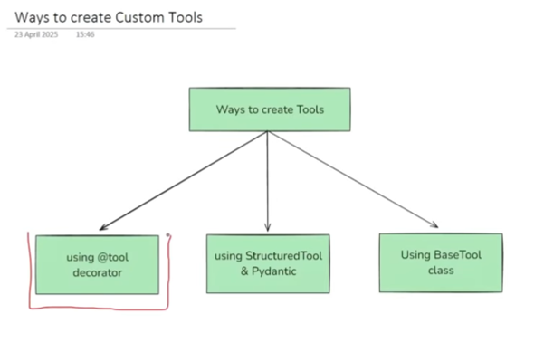

Creating a Custom Tool Using the @tool Decorator
This is the simplest and most commonly used method to create a custom tool in LangChain.
Three-Step Process
- Define a Python Function
Write a normal Python function that implements the tool’s logic.
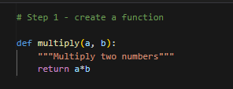
- Add Type Hints
Specify input and output types using Python type hints. This helps the LLM understand what kind of data to send and what to expect in return.
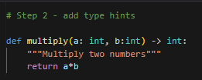
- Apply the @tool Decorator
Adding the @tool decorator converts the function into a LangChain-compatible tool.
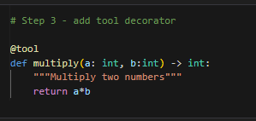
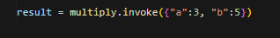
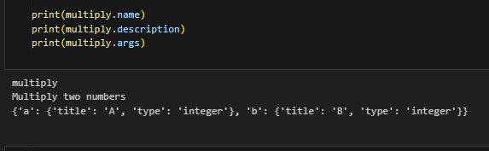
Role of the Docstring
Although optional, adding a docstring is highly recommended. The docstring becomes the tool’s description, which the LLM uses to decide:
- What the tool does
- When it should be used
Key Idea
Tool logic + type hints + @tool decorator = a usable LangChain tool
Once created, the tool behaves like a runnable object and can be invoked using the invoke() method with a dictionary of inputs.

Tool Attributes
Every tool in LangChain exposes three important attributes:
- Name – Usually the function name
- Description – Taken from the function’s docstring
- Arguments – Derived from type hints or schemas
These attributes are available for both custom tools and built-in tools (such as DuckDuckGo search), ensuring consistent behavior.

How LLMs See Tools
When a tool is connected to an LLM, the function logic is not sent to the model. Instead, LangChain converts the tool into a JSON schema.
This schema includes:
- Tool name
- Tool description
- Input properties
- Required fields
- Data types
The LLM relies entirely on this schema to decide whether to call a tool and how to construct its inputs. This is why clear descriptions and accurate type definitions are critical.
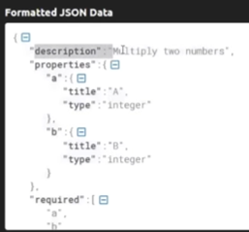

Structured Tools Using Pydantic
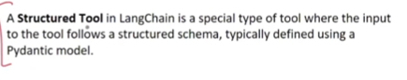
Structured tools provide a more strict and production-ready way of defining custom tools.
What Is a Structured Tool?
A structured tool enforces its input format using a Pydantic model. This ensures:
- Strong validation
- Clear constraints
- Better reliability in production
How It Works
- Define a Pydantic BaseModel that specifies the input schema
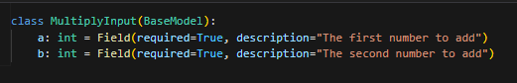
- Write the tool logic as a function
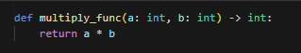
- Create the tool using StructuredTool.from_function
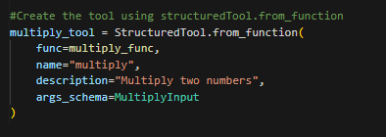
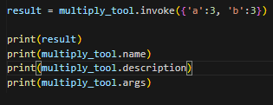
In this approach, the tool’s name, description, and argument schema are defined explicitly rather than being inferred from the function.
When to Use Structured Tools
- When incorrect inputs can cause failures
- When strict validation is required
- When building production-grade agents
For most learning and experimentation scenarios, the @tool decorator is sufficient. Structured tools are mainly useful in enterprise setups.

Creating Tools Using the BaseTool Class
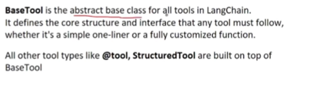
This is the most advanced and flexible method for creating custom tools.
What Is BaseTool?
BaseTool is the abstract base class for all tools in LangChain. Every tool—built-in or custom—ultimately inherits from BaseTool.
How This Approach Works
- Create a class that inherits from BaseTool
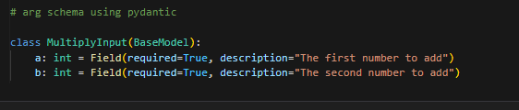
- Define:
  - name
  - description
  - args_schema (usually a Pydantic model)
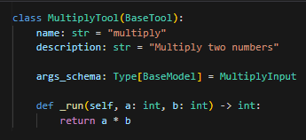
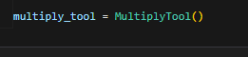
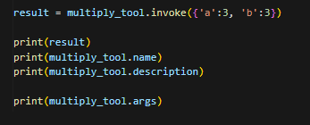
- Implement the _run() method (mandatory)
This approach allows deep customization, including:
- Advanced logic
- Internal state
- Asynchronous execution
When to Use BaseTool
- When you need async tools
- When concurrency handling is required
- When building complex, production-level systems
For most use cases, this approach is not necessary. The @tool decorator covers around 80–90% of scenarios.

Toolkits in LangChain
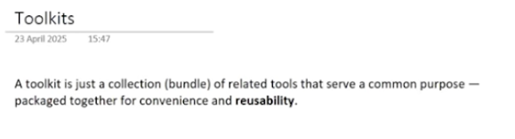
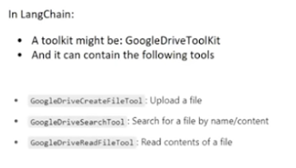
What Is a Toolkit?
A toolkit is a collection of related tools packaged together for convenience and reusability.
Example
If you build multiple tools related to Google Drive, such as:
- Upload file
- Search files
- Read file content
You can group them into a single Google Drive Toolkit.
Benefits of Toolkits
- Better organization
- Easier reuse across applications
- Simplified tool management
Creating a Custom Toolkit
To create a toolkit:
- Build two or more related tools
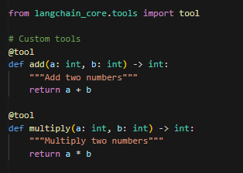
- Create a class representing the toolkit
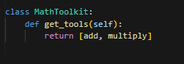
- Implement a get_tools() method that returns a list of tools
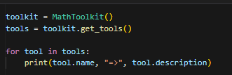
Once created, the toolkit can be reused across multiple agents and applications.

Summary
- Custom tools are required when built-in tools do not match your use case
- Tools enable agents to interact with APIs, databases, and business logic
- LangChain provides three main ways to create custom tools:
  - @tool decorator (simple and common)
  - Structured tools with Pydantic (strict and production-ready)
  - BaseTool inheritance (advanced and flexible)
- Toolkits group related tools for reuse and cleaner architecture
This completes the foundation for tools and toolkits. The next step is tool calling, where these tools are connected to LLMs and used dynamically by agents.

